** Salesforce Administrator**

**Project**

**Name: Shruti Singh**

Customized and configured the App

**(Travel App)** to record the details

of the travelers and approve their request

**Building a Custom Travel Approval App**

**Introduction**

This company needed a custom Travel Approval App to replace their outdated process of managing travel requests via emailed spreadsheets. The lack of central repository and enforcement of the approval process resulted in poor visibility and the inability to track or report on travel activities across the organization.

To address these issues, the company required a solution that met the following:

* Employees must submit electronic requests for future travel in the system.
* Each request should include estimated expenses for airfare, hotels, rental cars and other travel-related costs.
* Request must be approved by the employee’s manager, with additional approval from a travel coordinator for out-of-state trips.
* Manager needs reports and dashboards to track key travel trends and KPIs.
* Both employees and managers must be able to access their travel requests, approvals and reports via mobile devices.

By the end of this project, I developed a fully functional prototype of the Travel Approval App that centralized travel requests and approvals, which will provide increased transparency and accountability.

**Steps**

# Created an app call Travel App

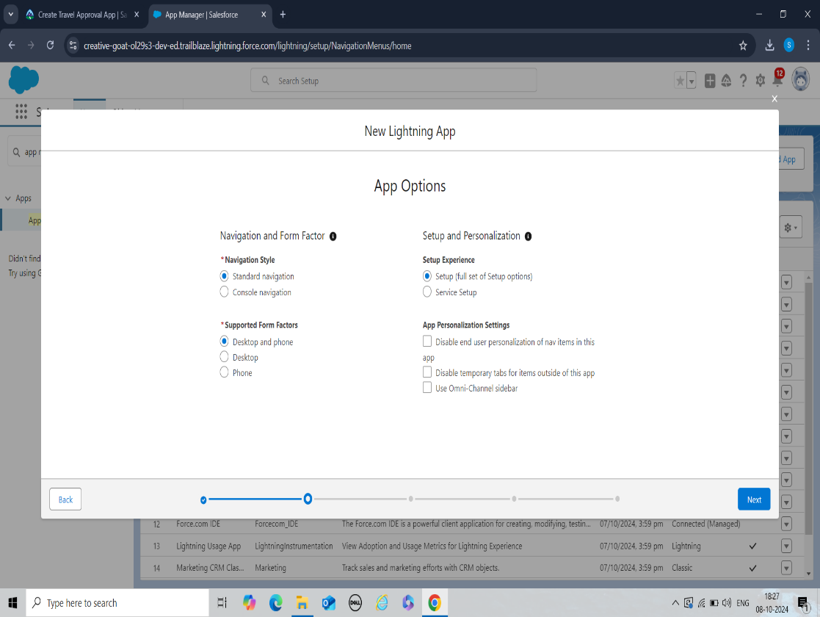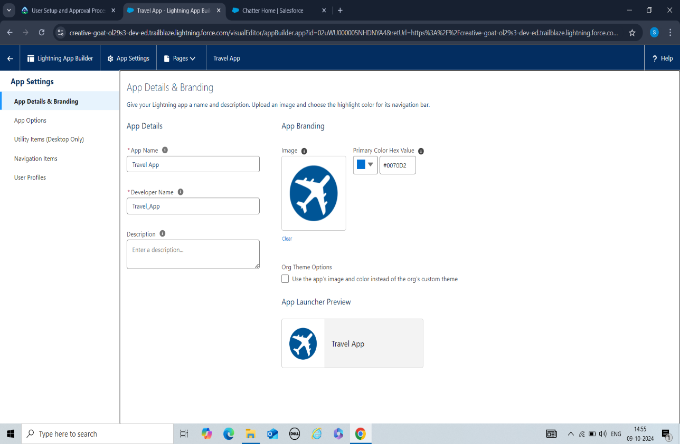First created an app through App Manager

****# Created Custom Objects

Since the company has many units, I have created custom objects through Object Manager.

1. 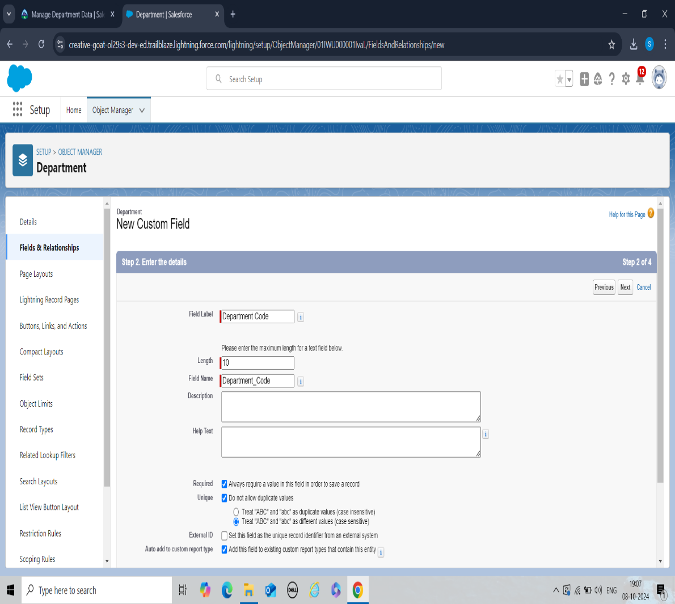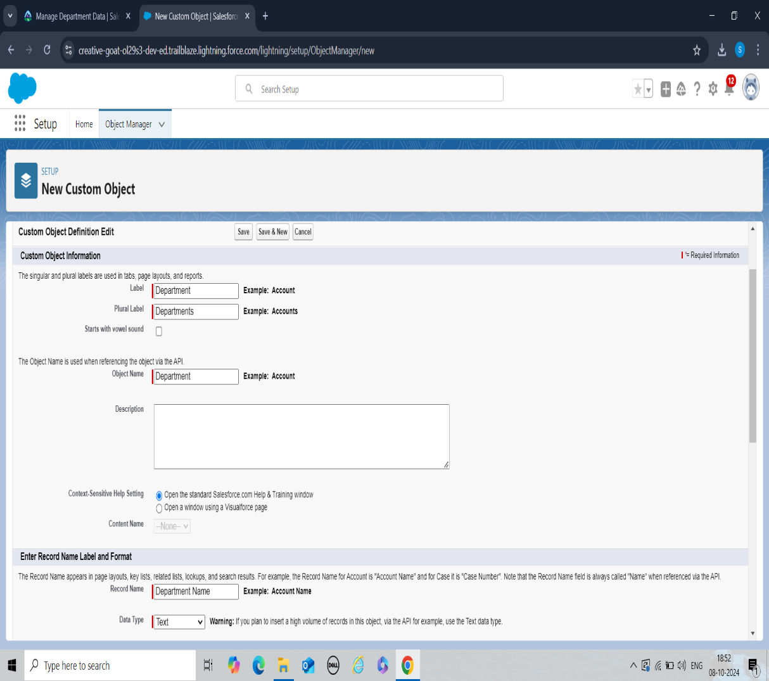**Department-** It stores information about the name of the departments and the cost center code.
2. **Travel Approval-** It stores basic information about where customers are traveling and trip duration.

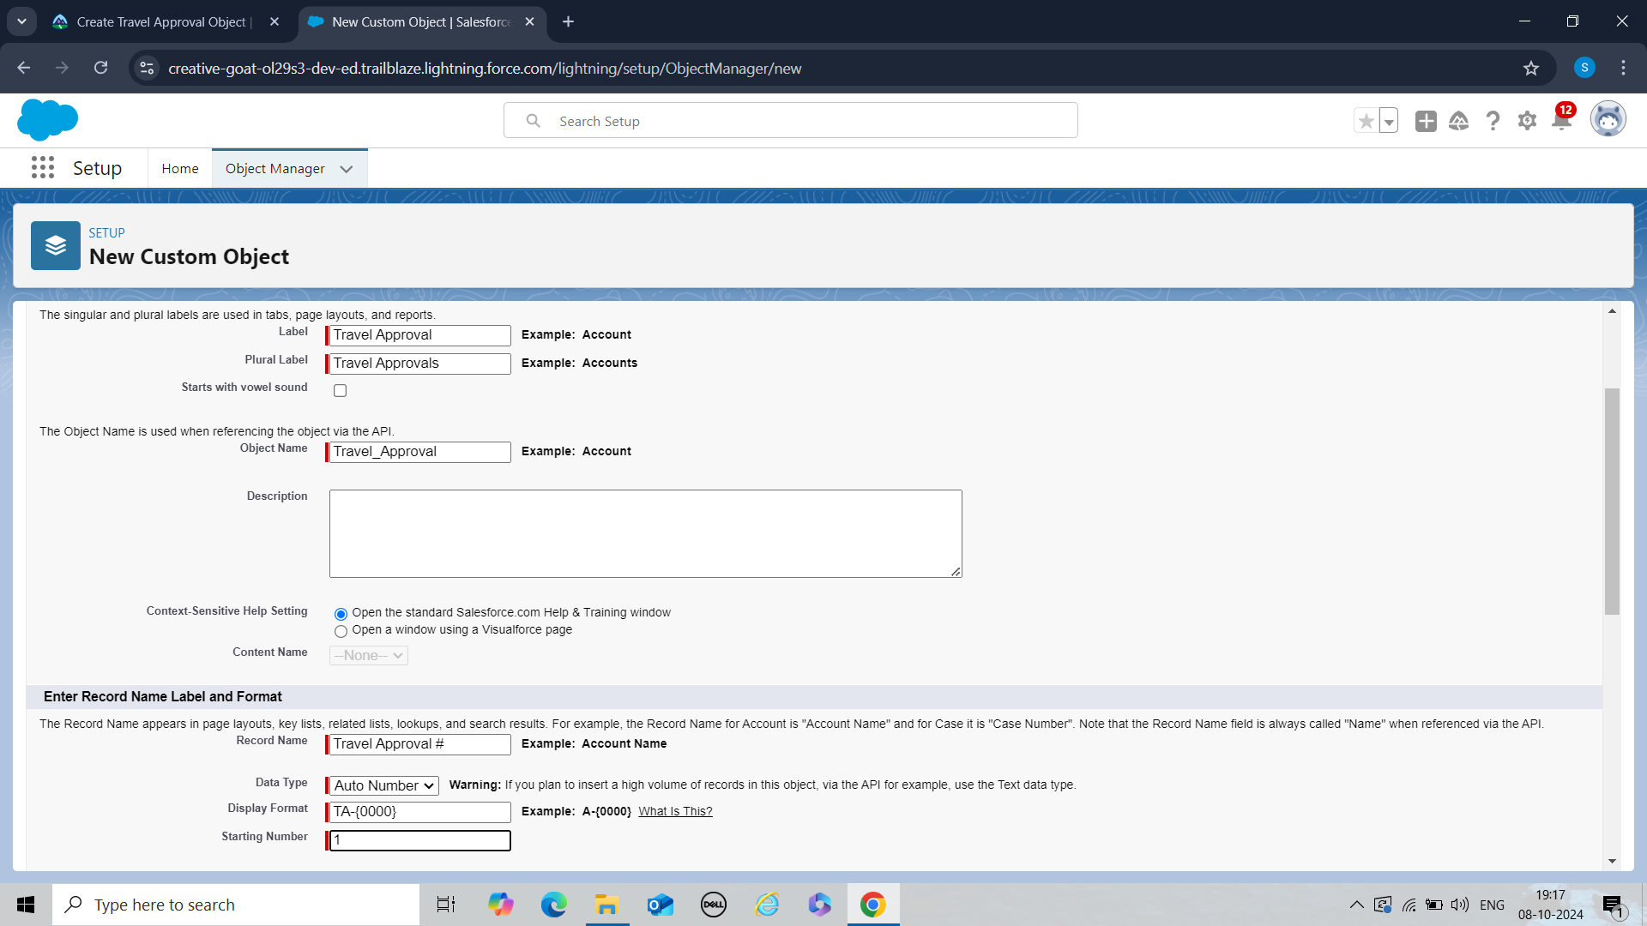

# Created Custom Fields

Created custom fields for Travel Approval Object by clicking on Fields and Relationships

1. **Purpose of Trip-** It stores the purpose of the customer’s trip with datatype **Text Area**.
2. 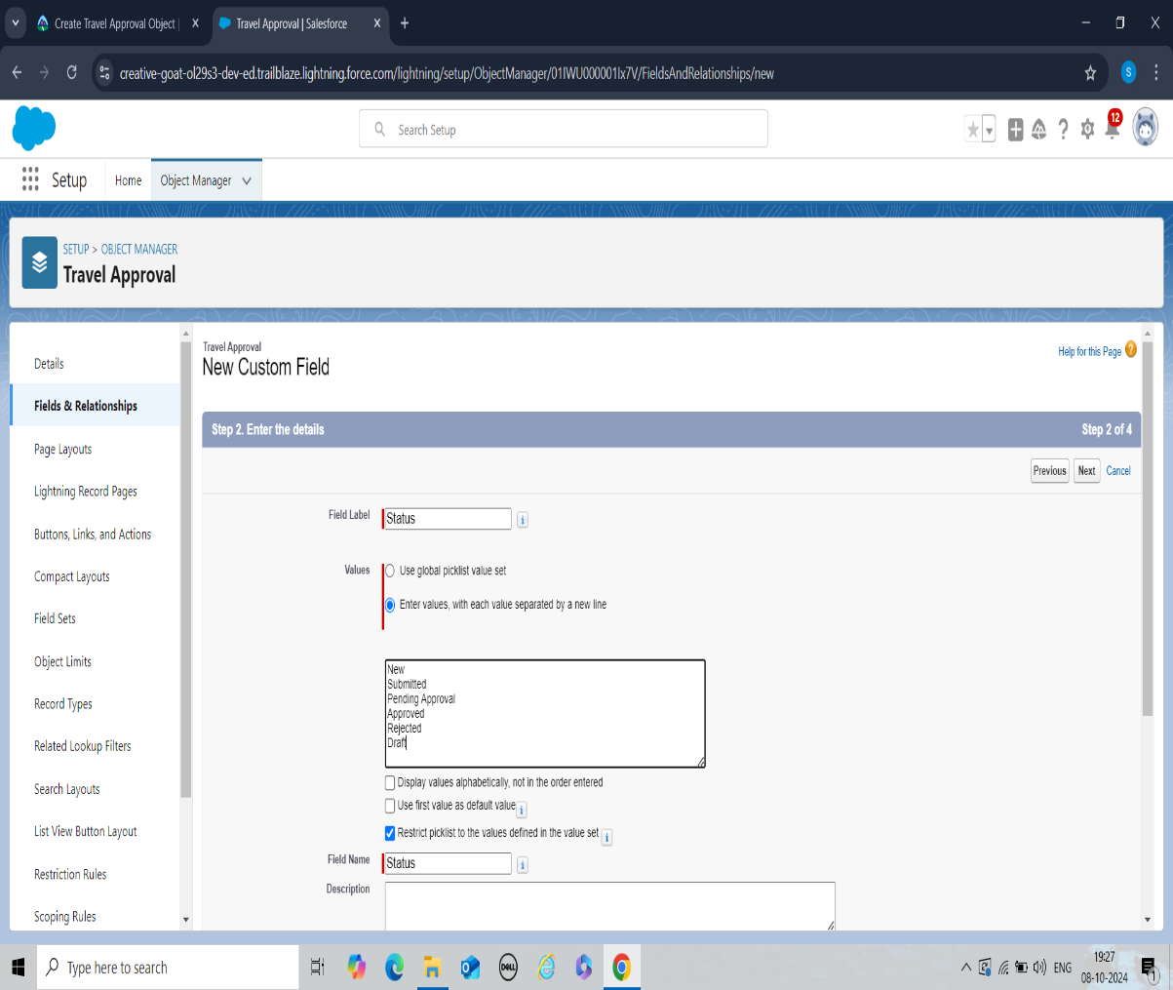**Status-** It stores the status of request for travel approval with datatype **Picklist**.

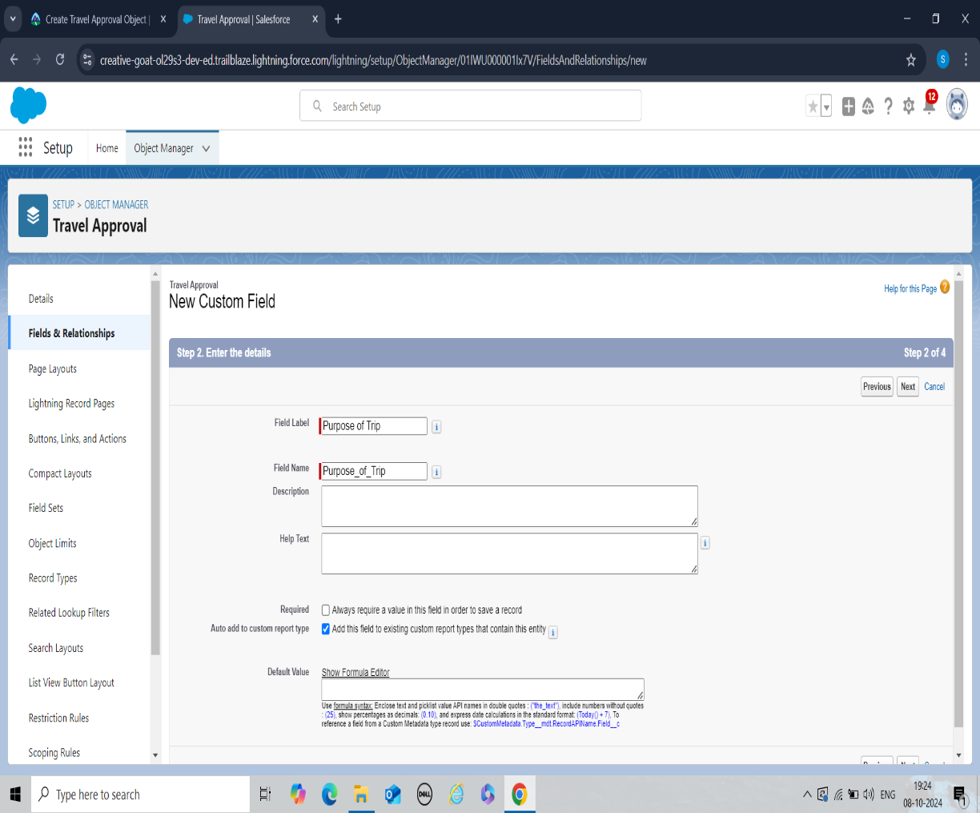

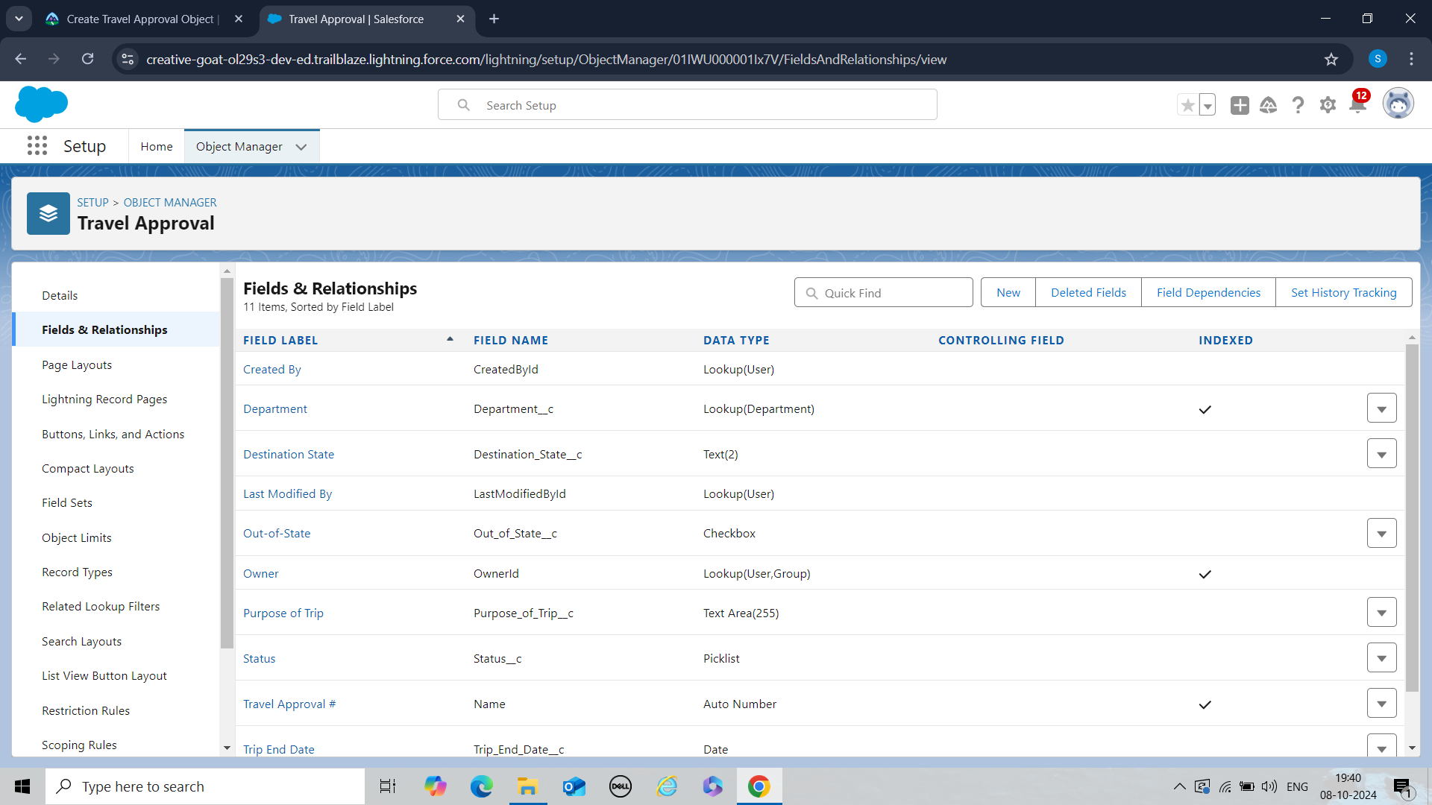****Created some more custom fields to store each detail or information separately and systematically as shown below with their datatypes

# Created Third Object

**Expense Items-** The purpose of adding this object was for the travel app to provide an estimate for trip costs such as airfare, hotel or rental car. Since we do not want it to be as a separate object it will be on the related field so that you can easily navigate to specific record.

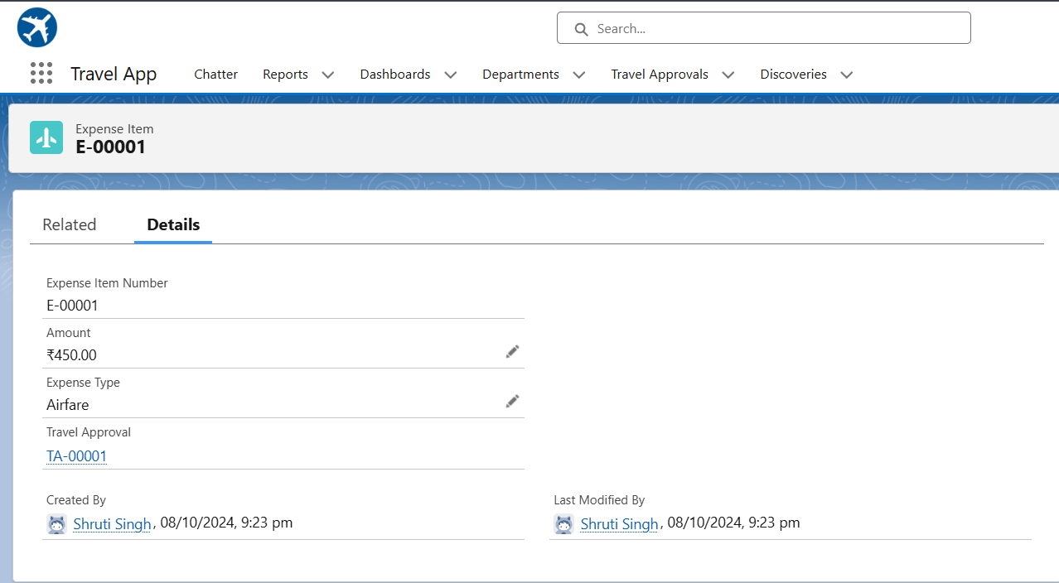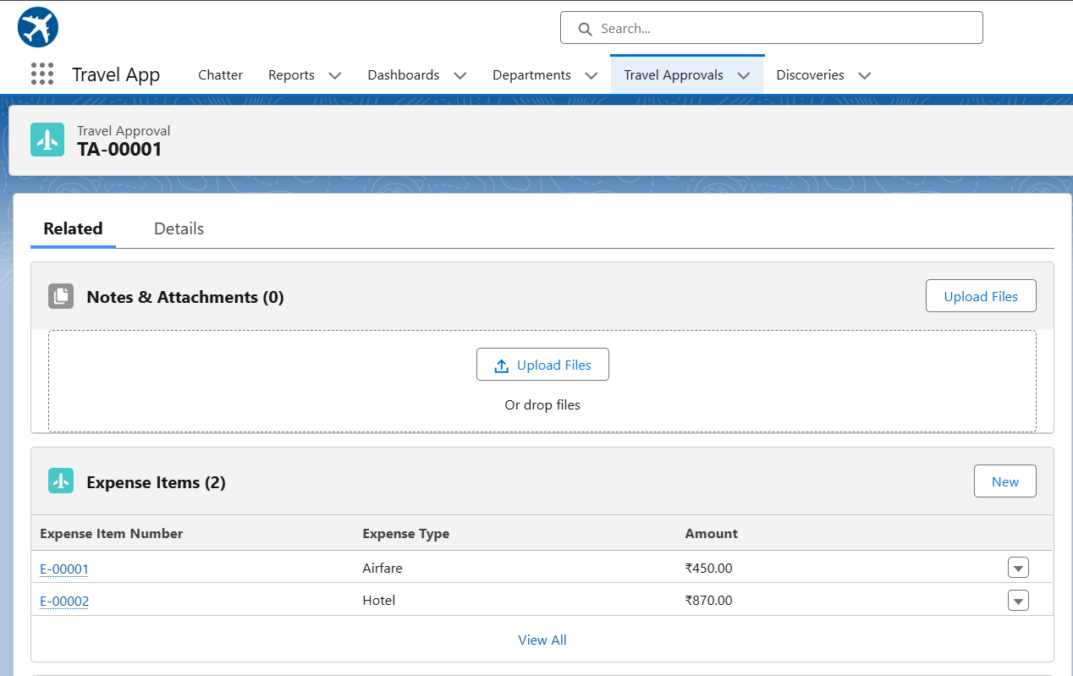This object has a master-detail relationship for each record under related is where you get the expense item

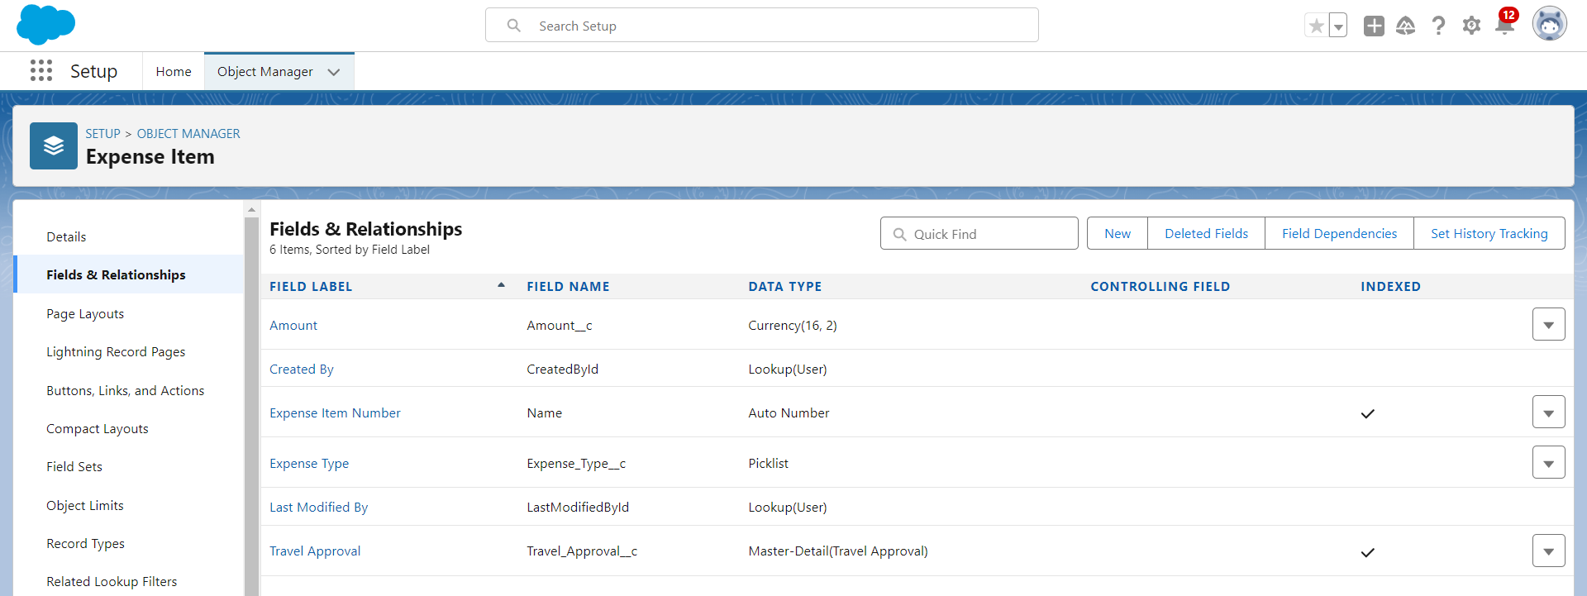****Created Custom fields for Expense Item Object

# Data Import

Imported the 16 records for the department object that were from the company’s spreadsheet and tested the App

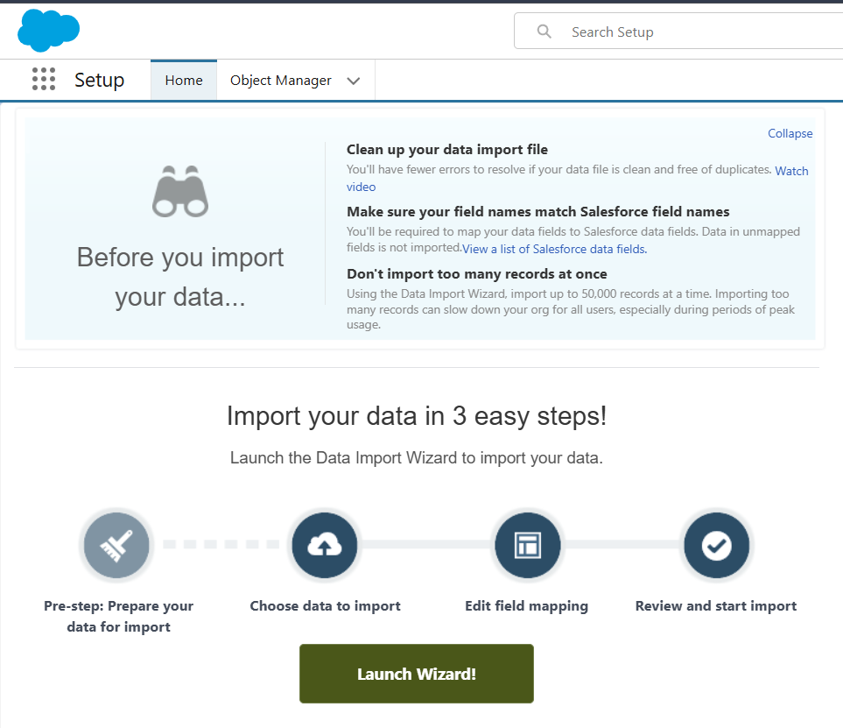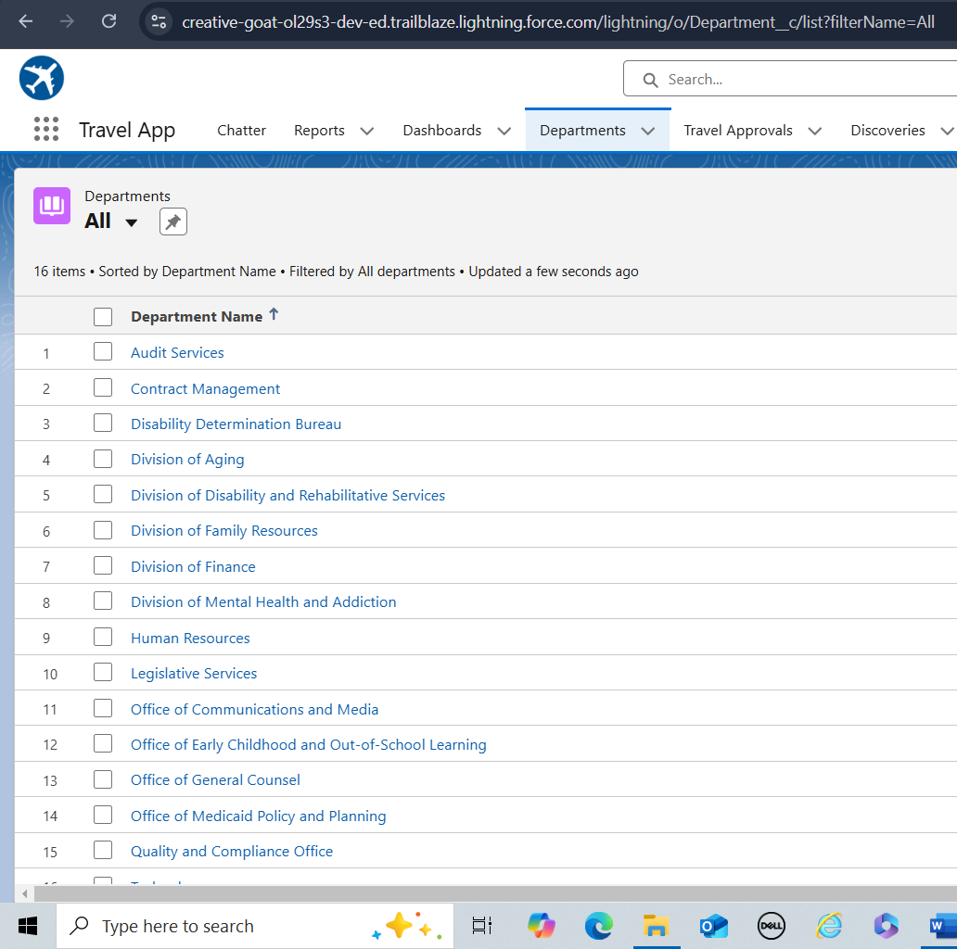****

# Created a User

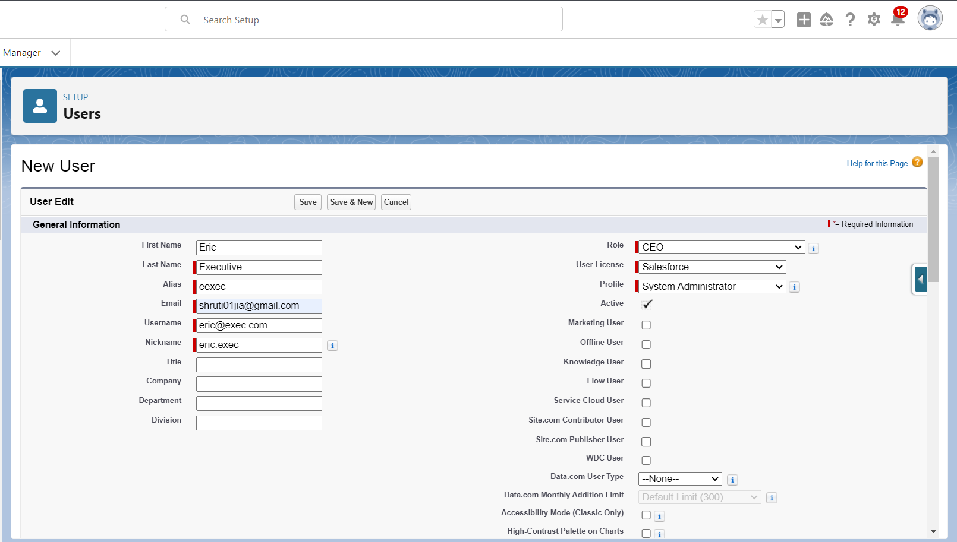The purpose of creating a user was to assign him with the duties of Salesforce Administrator for testing the app

# Created Search Layout

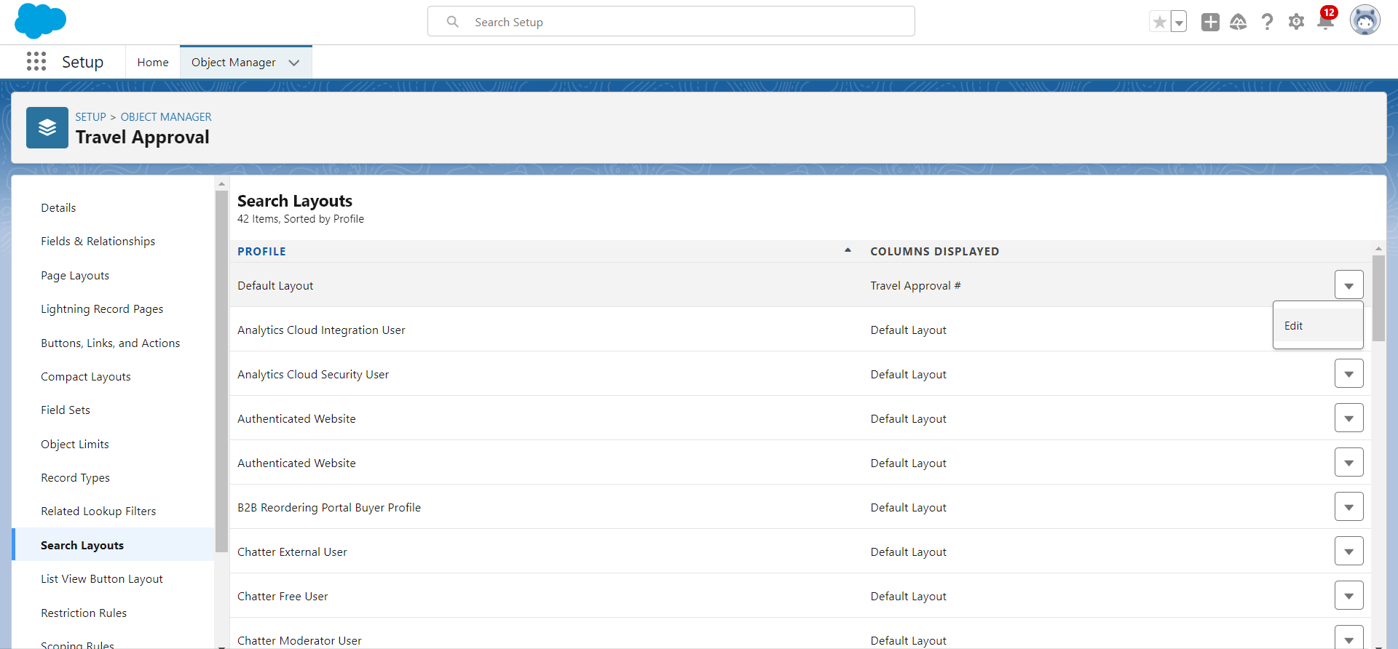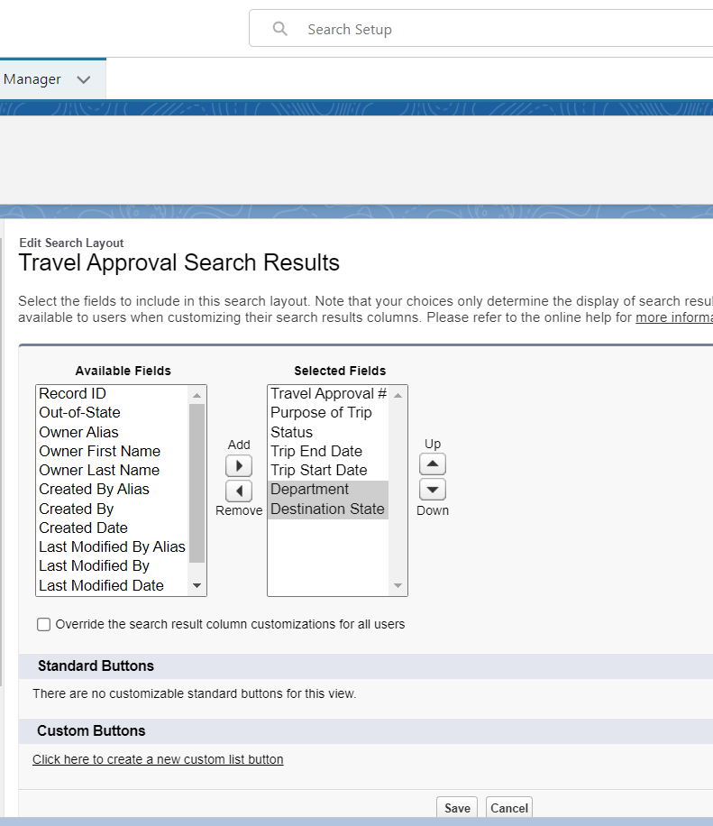Edited the default layout in Search Layout option to make certain fields available on search result by moving fields from **Available Fields** to **Selected Fields**

 # Created Compact Layout

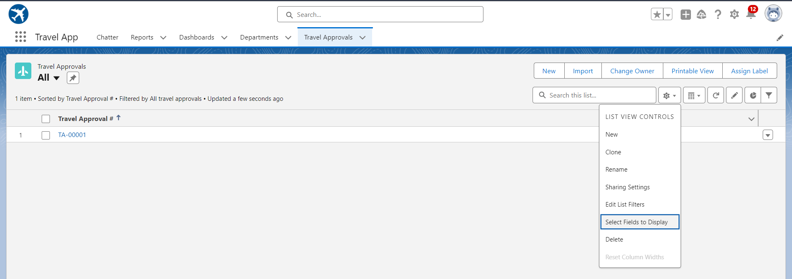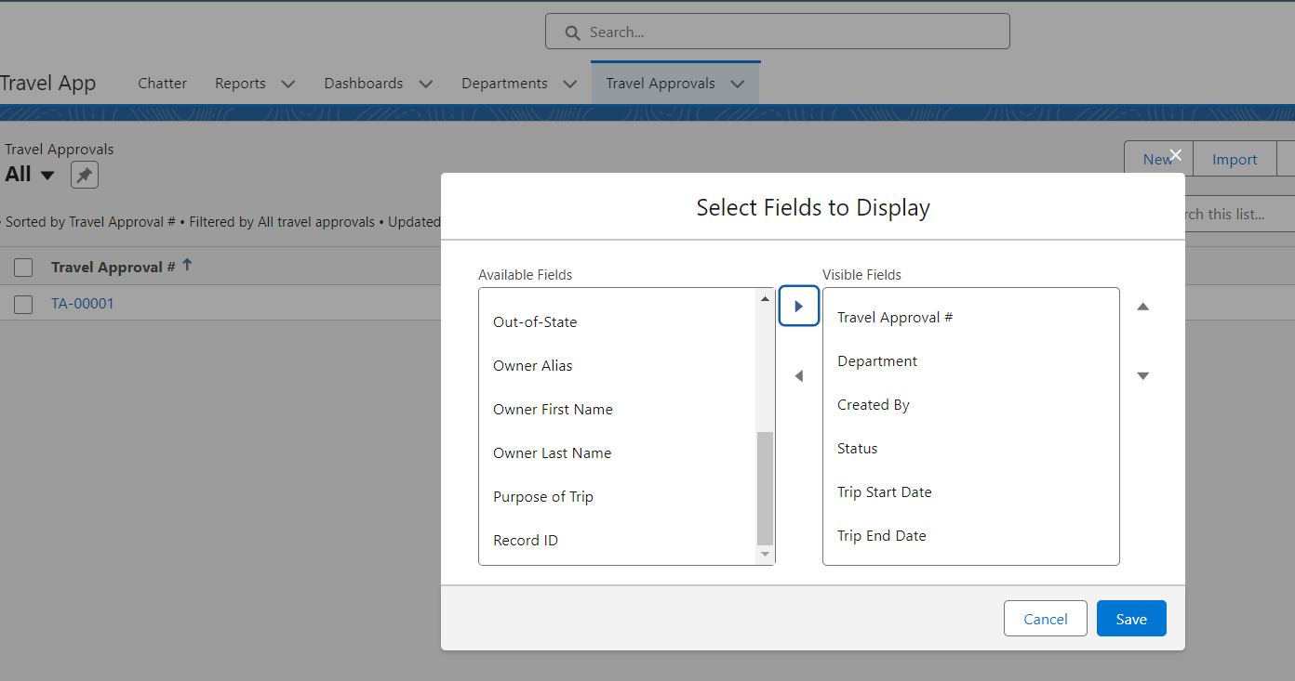Created compact layout for displaying some important fields on the view page so that we don’t need to open the whole record

# Created a new List View

Created a new list view for all the user to easily find the records with trips that are out-of-state.

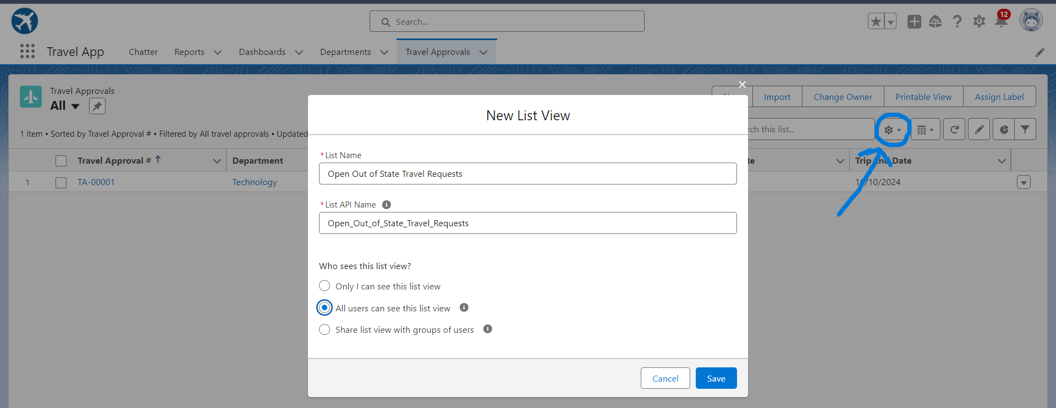Click the Gear icon and select **New**. Give a suitable name to the list view.



Then click on Filter Icon to create the list view with the help of a condition

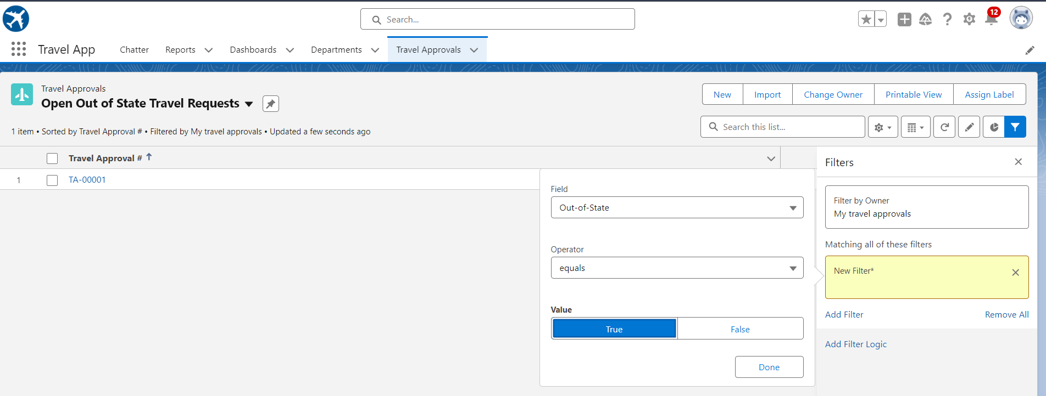# Created Page Layout

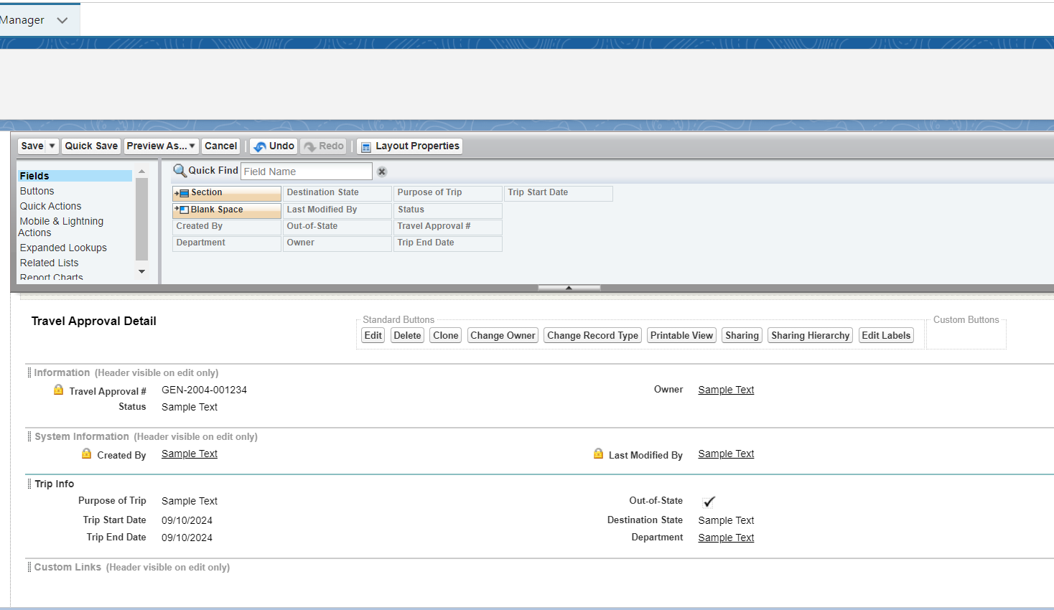Designed and implemented a user-friendly page layout to enhance clarity and usability when creating new travel approval records.

# Enabled Feed Tracking

Enabled feed tracking for the selected fields to track what changes are made on them and who made the changes.

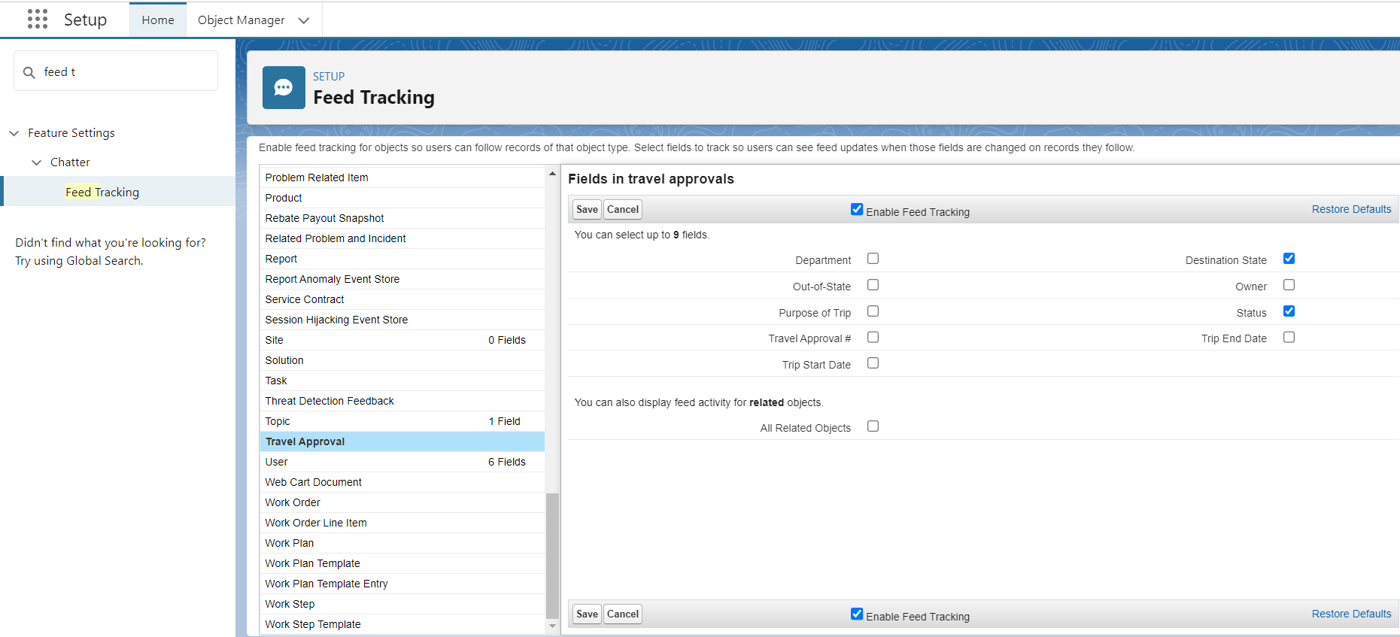

# Created Validation Rule

Created a validation rule using a formula on Travel Approval object to show the error and store only those records whose **Trip End Date** is greater than its **Trip Start Date** and display an error message every time the output is **True**.

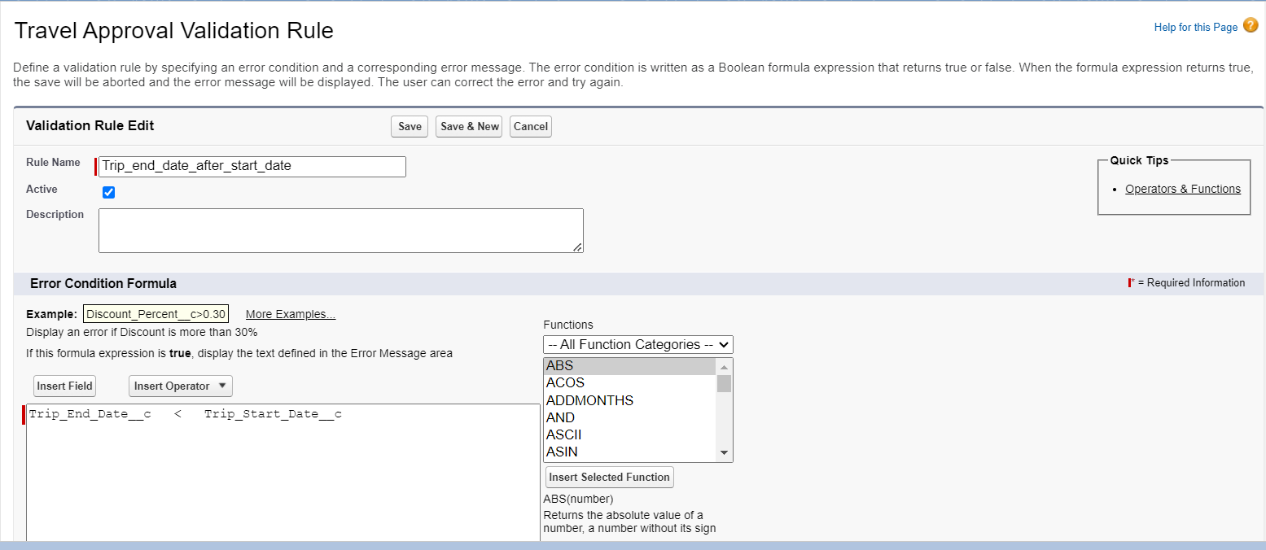# Created Roll-Up Summary Field

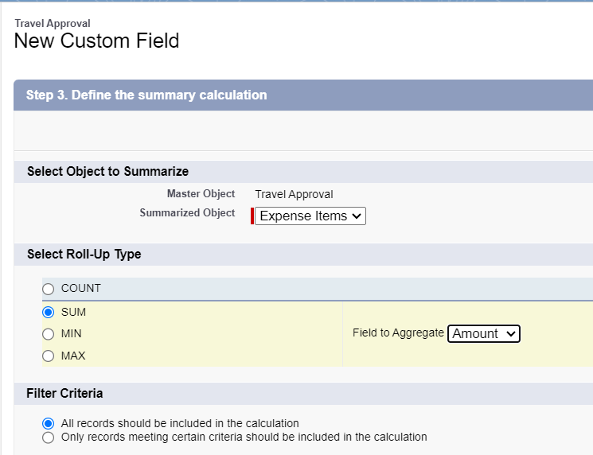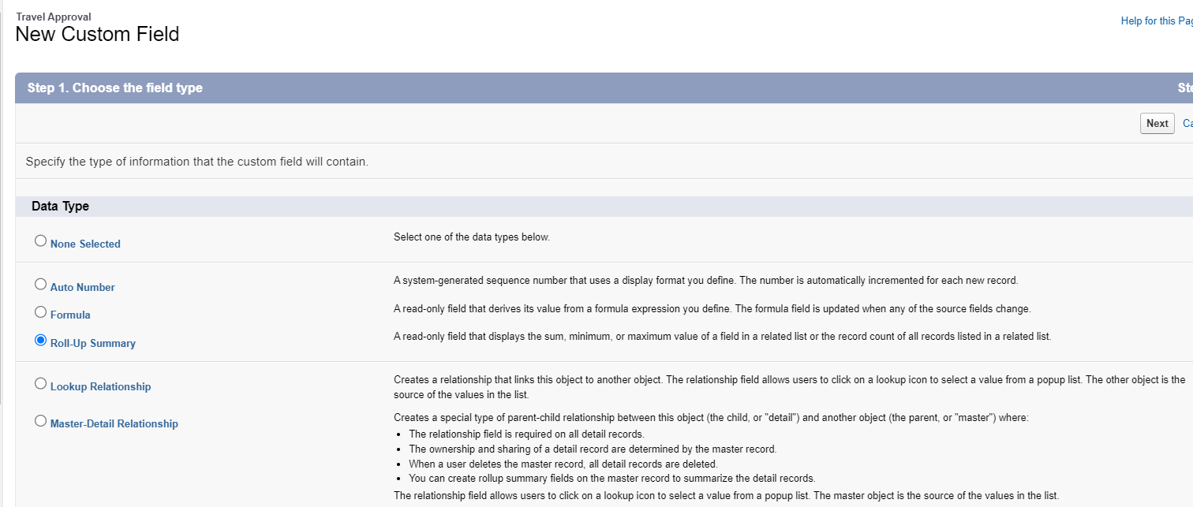Created a new roll-up summary custom field on Travel Approval object to calculate and display the Sum of Amount of Expense Items

# Created a Flow

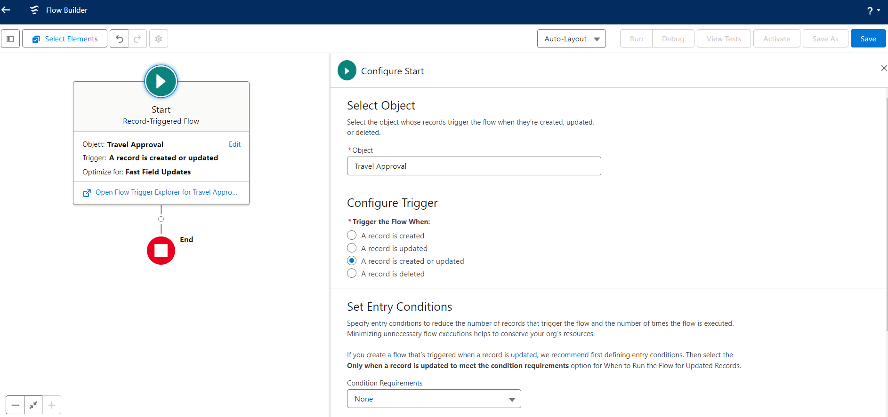Created a **Record-Triggered Flow** which will be triggered when a new record is created or updated when the checkbox for out-of-state is selected and the destination is not equal to TX. Whereas when the checkbox is not selected and destination is equal to TX.

An element **Decision** is made (**Is Travel Out of State?**) to return two different outcomes for the record which are for out-of-state and which are for in state.

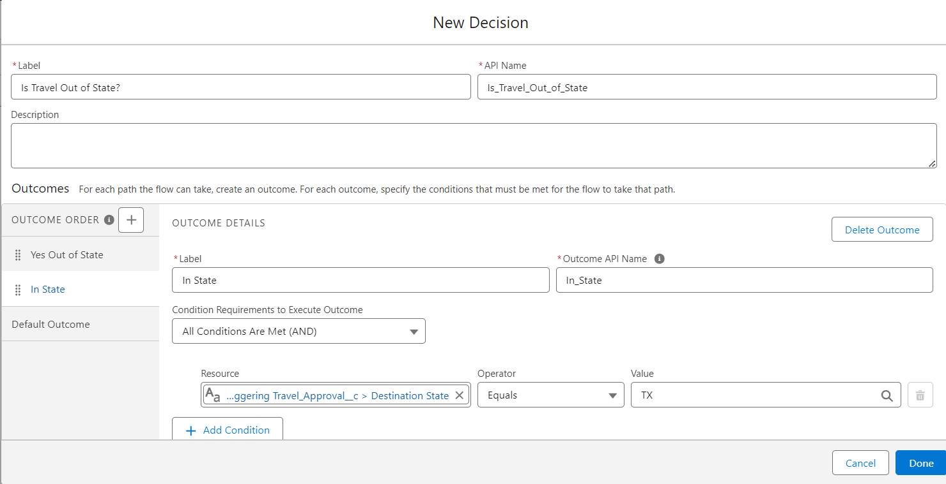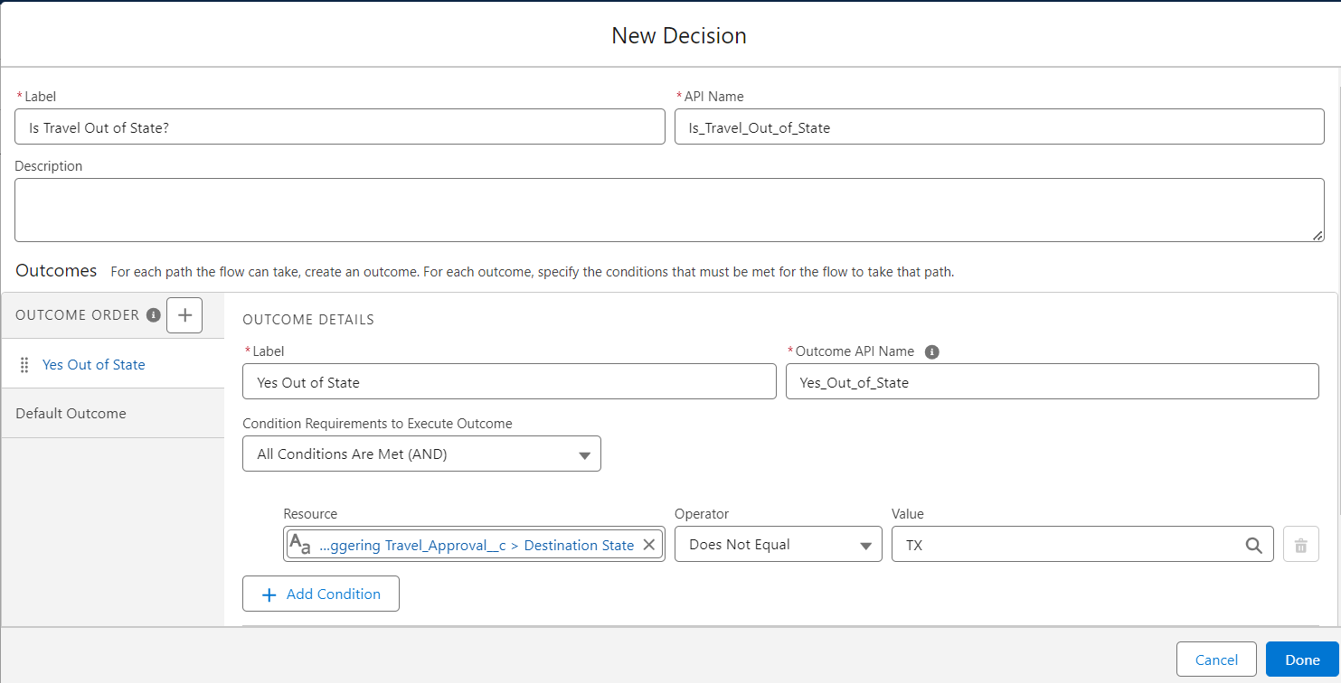Each decision has one **Action** i.e. Update Record

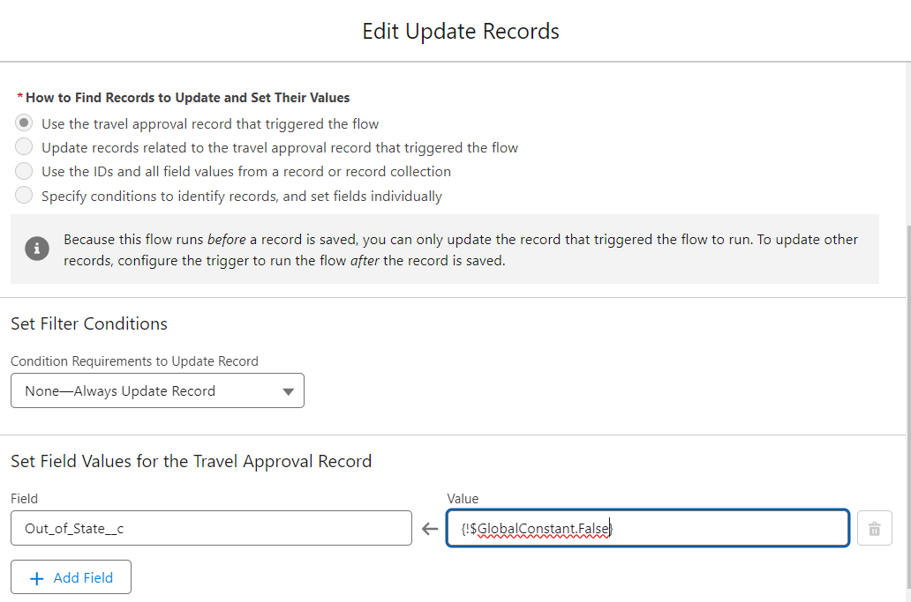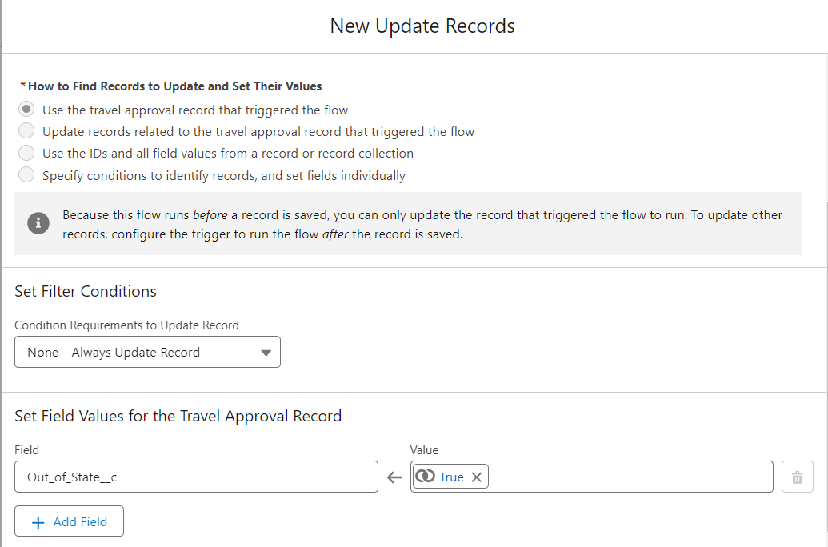

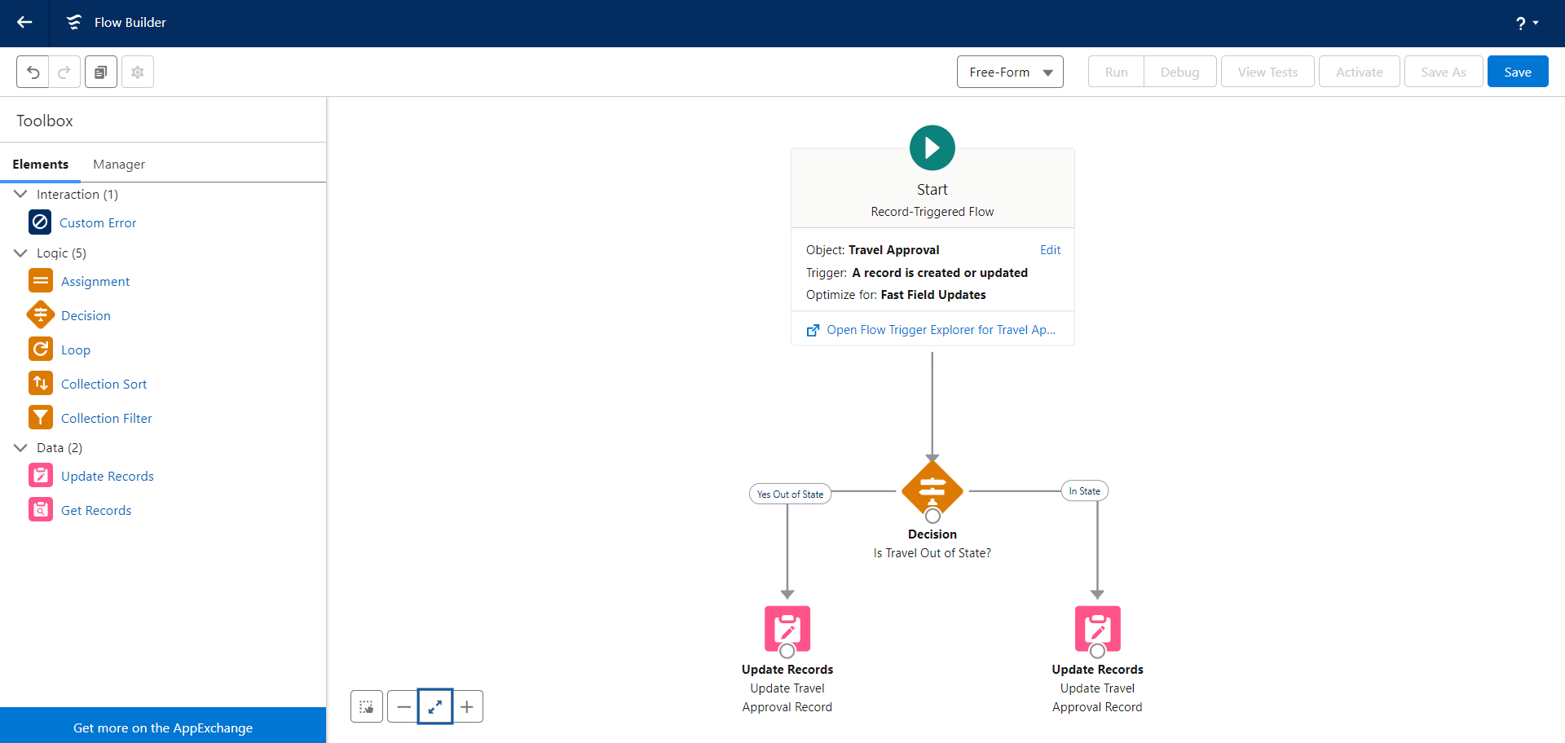

# Created Approval Process

Created Approval Process with Step 1 named as **Travel Approval Request** with the criteria, if Total Expenses greater than 0.

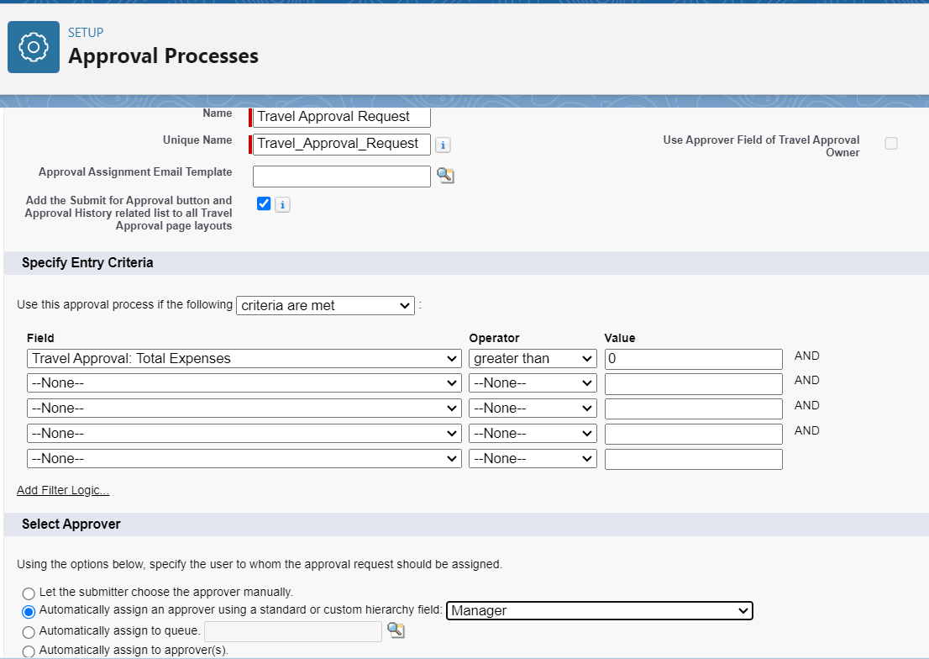All travel approvals are sent to the employee’s direct manager for approval.

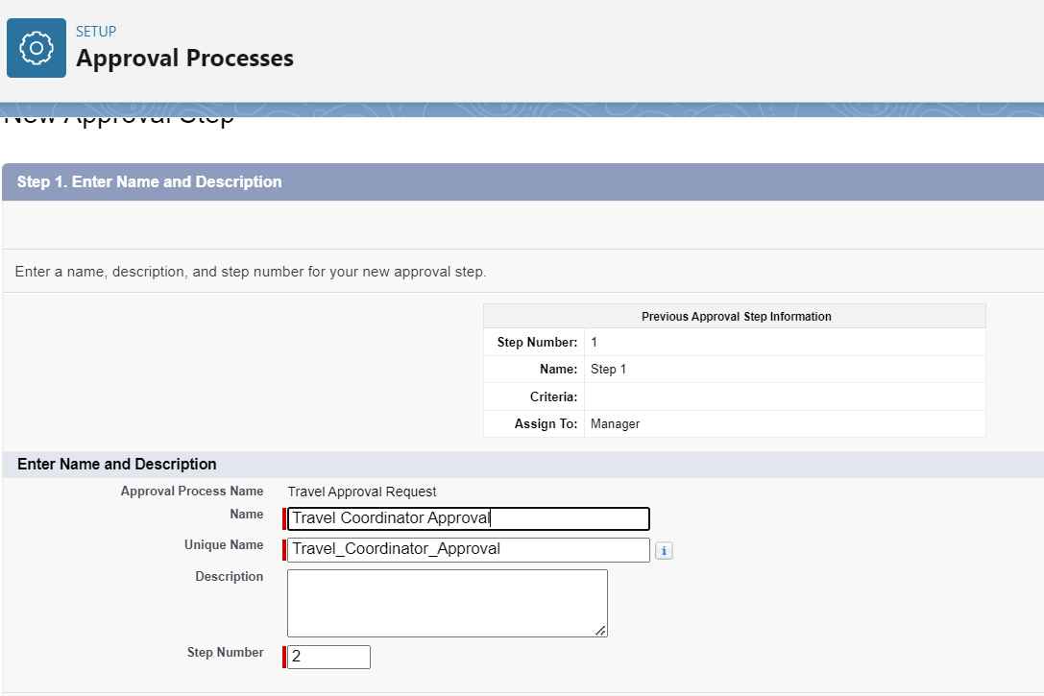Created Step 2 of the approval process named as **Travel Coordinator Approval** with the criteria, if Out-Of-State equals to true.

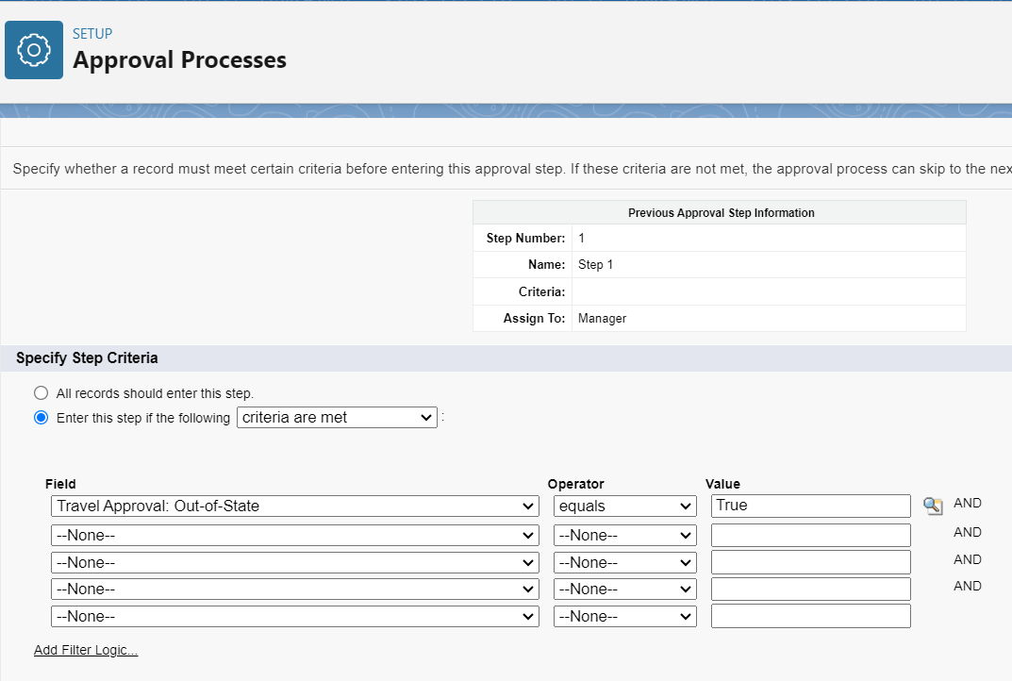

Assigned myself as the Travel Coordinator to approve the requests that are out-of-state.

# Created Actions for Approval Process

* Created Final Approval action of the approval process which will execute when the request will be approved by all approvers.

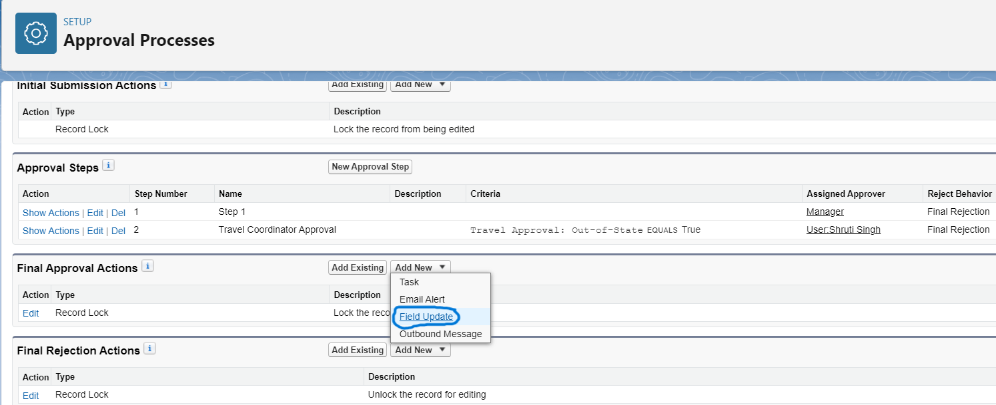

The action is Field Update named as ‘Set Status to Approved’ which will change the **Status** field as ‘Approved’ if, the request for out-of-state trip is approved.

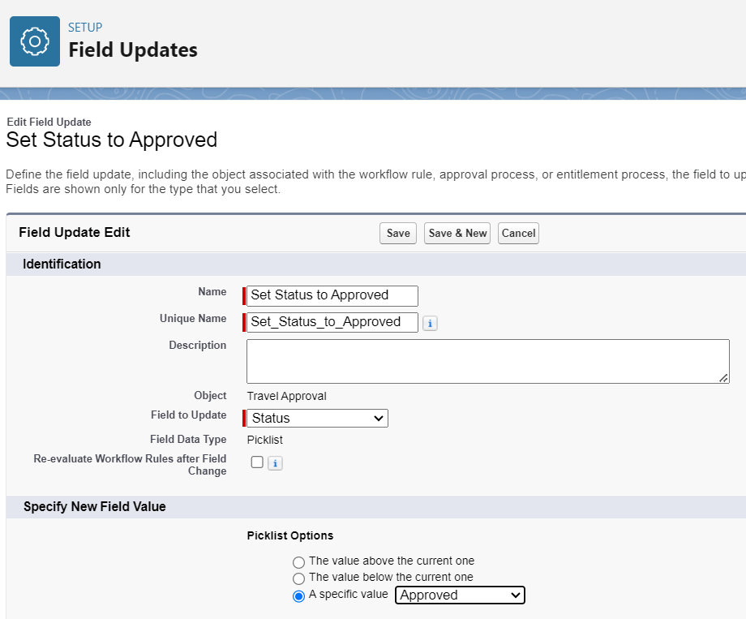

* Created Final Rejection action of the approval process which will execute when the request will be rejected by all approvers.

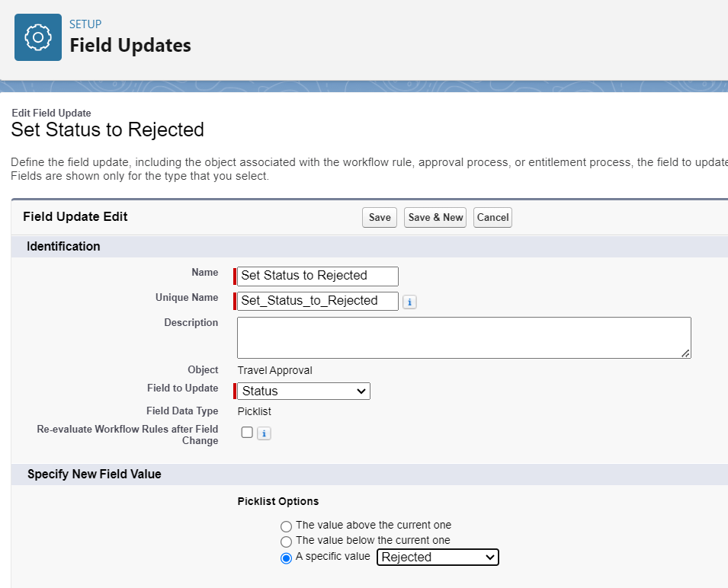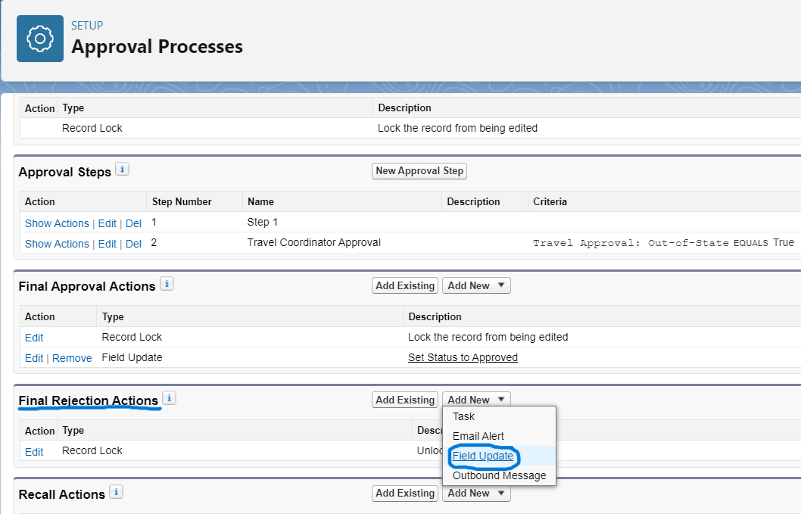

The action is Field Update named as ‘Set Status to Rejected’ which will change the **Status** field as ‘Rejected’ if, the request for out-of-state trip is rejected.

# Enabled Email Approval Response

When an employee submits their travel approval request, an email is sent to the next approver in the approval process to notify them of the request. That email includes a URL link to the travel approval record so that the approver can access the details easily. It is also possible to allow the approver to just respond to the email with text like APPROVE, YES, REJECT, NO, and so on.

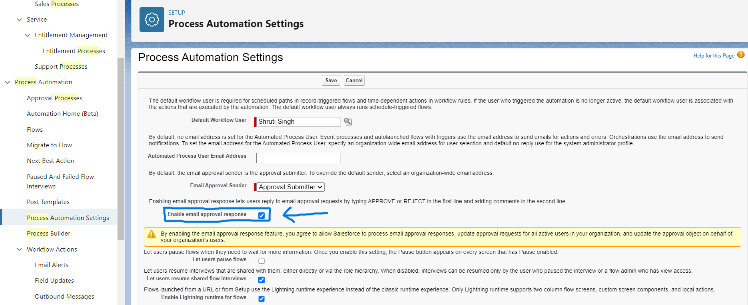

# Created Report for Travel Approval Object

Created a report to show the number of travel approval requests by department. For that, first we imported the travel approval data to the salesforce org through Data Import Wizard.

* Then click on App Launcher from Home page and select Travel app
* Click on Reports tab and select New Report
* 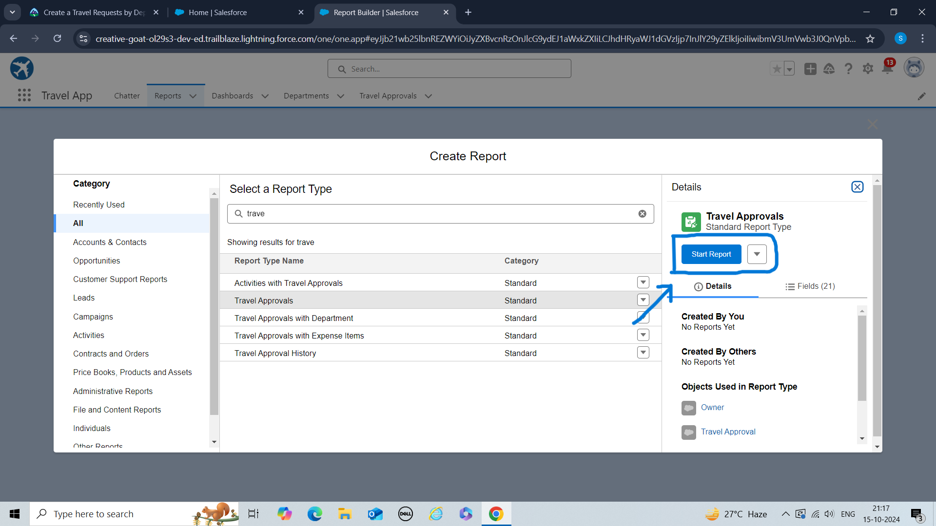Select Travel Approval as a Report Type and click Start Report
* Enter and select the following fields to the Add column… box, in order:
* Status
* Out-of-State
* Destination State
* Trip Start Date
* Trip End Date
* Search for the **Department** Field under Group Rows in the Outline Section and add it.
* 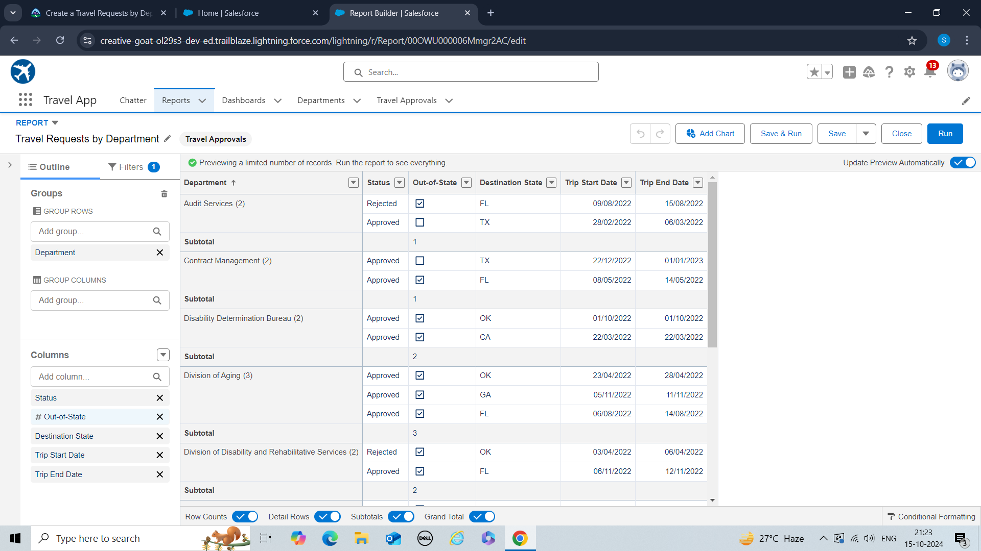Save the report with the name **Travel Requests by Department** and save it in **Public Report** Folder**.**

Created another report with the travel approval report type,

* Enter and select the following fields to the Add column… box, in order:
* Status
* Out-of-State
* Destination State
* Trip Start Date
* Trip End Date
* Search for the **Trip End Date** field under Group Rows in the Outline Section and add it
* In the preview pane, click the **down arrow** in the Trip End Date heading and select **Group Dates By | Calendar Month.**
* Search for the **Out-of-State** field under Group Rows in the Outline Section and add it
* Save the report with the name **Travel Requests by Month** and save it in **Public Report** Folder

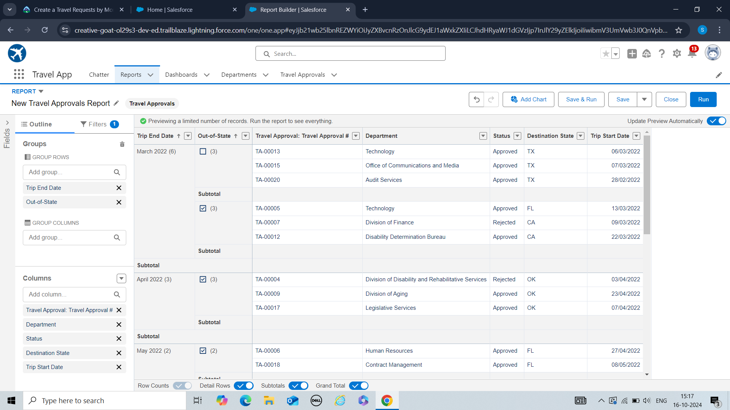

# Created Dashboard

The purpose of creating a dashboard is that it provides an interactive visual display of key metrics and trends. It takes the analysis to the next level by placing your reports on a Salesforce dashboard for quick and easy viewing.

* Click on Dashboard tab and select New Dashboard
* 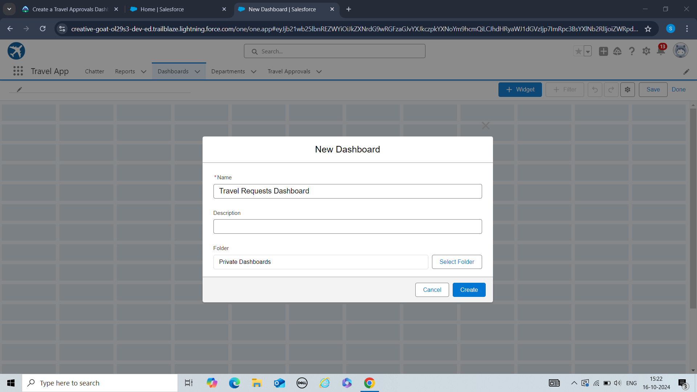Name the dashboard as **Travel Requests Dashboard** and save it in **Private Folder.**
* Click **+ Widget** and select **Chart or Table**.
* Click the **Travel Request by Department** report and click **Select**.
* Make sure the Y-Axis is set to **Department** and the X-Axis is set to **Record Count**.

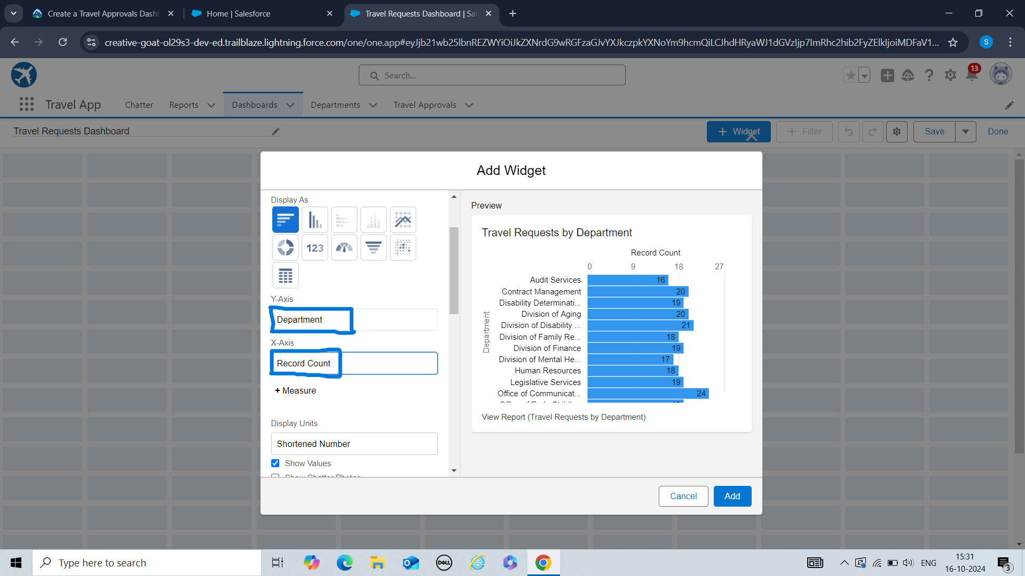

* Click **+ Component** to add our other report.
* Select the **Travel Requests by Month** report and click **Select**.
* Display it as **Stacked Vertical Bar Chart** and sort by **Trip End Date.**

The dashboard will look like the following.